MDCA Operations Guide (Revision1 06Jun24)
This document is intended to provide both Officers (Exec) and Members (existing and new) with a general understanding of their rights and obligations as governed by the new Incorporated Societies Act 2022 (the Act) It is intended to be a companion document to the lengthy 15+ page Constitution (the Constitution), but not a replacement for it.
The Constitution is a “living document” and can be amended in accordance with the Act by a 2/3rd majority of Members present and voting at a General Meeting. Any motion to amend must be supported by 25% of Members and submitted in writing to the Committee at least a month prior to the General Meeting.
This Operations Guide may be amended by the Executive Committee as required, with any modifications being shared with and approved by membership via a simple majority vote.
The publication Members Meetings by Mark von Dadelszen provides additional guidance for meetings and meeting procedure, and is retained for reference by the Chairperson.
Name and Status
- MDCA is an Incorporated Society and is not registered as a Charitable Entity. MDCA is a not-for-profit organization funded by a combination of membership dues, TDC grants and resident donations.
- MDCAs registered address is: Māpua Community Hall, 72 Aranui Rd, Māpua 7005, NZ
Purpose (Objectives)
The primary purpose of the Society as defined in the Constitution is to initiate and organise actions that contribute towards making our Community a better place for both current and future generations:
Actions include but are not limited to:
- Promoting and fostering interest in the social, economic, environmental and cultural life of Māpua and surrounding districts
- Encouraging public discussion on the socially, economically and environmentally sustainable development of Māpua and districts, commensurate with the preservation of its unique qualities and desired lifestyle of residents
- Serving as a channel of communication with local, regional and National Government, including the Tasman District Council (TDC) and any other statutory or interested organisations, in as much as they may affect those who live in the district
- Assisting membership to better understand the process/timelines for preparing public submissions including but not limited to TDC Policy Matters, Residential and Commercial Plan/Zoning changes, Parks & Reserves management, Roading and Pathways, Public Transport, Liquor Licencing, District Health Board matters, Environmental and Climate resiliency concerns )
- Collecting and disseminating information on matters pertaining to these objectives and any other matters of interest or concern to the community
In undertaking these actions the society will:
- carefully consider its position with respect to significant social and/or commercial matters impacting our Community
- focus on ensuring members have all available information and seek clarification as needed from all relevant stakeholders
- represent its membership on agreed positions
- provide a forum within which our members and the community in general can listen to proposals and our residents’ different perspectives.
- not claim to speak on behalf of the wider Community
Membership
- Membership of MDCA is restricted to residents of “Māpua and Districts”, and this area is now clearly defined by a map of the MDCA Membership Area (Appendix 1)
- When applying to join MDCA, new or renewing Members must email communicate with the Treasurer via text/email/mail stating their intention to become a Member, providing their name, address, email and phone number, together with payment of the required membership dues. The Treasurer will keep records of all members per the requirements of the Act.
- If Members do not pay their dues within 3 months of the start of the annual membership period (July 1st) they will considered non-financial and lose voting rights. If payment of arrears is not made with 4 months (30th October), membership will be terminated.
- Life Membership is reserved for Members who have been recognised for their significant contributions for an extended period of time, generally 10 years or more, and where it can be demonstrated that their contributions have meaningfully advanced the aims and objectives of the Society. Life Membership is bestowed by a 2/3rd majority of members present at the AGM.
Meetings and Record-Keeping
- All residents/visitors are welcome to attend MDCA General (Public) Meetings, but only paid-up (financial) Members can raise motions and/or vote.
- MDCA General Meetings will continue to be held monthly from February through to December, with meeting notices distributed to members via email at least 3 working days in advance of the meeting.
- The Quorum for General Meetings (including AGMs) is 10 financial members, including no fewer than 3 Exec Members. General Meetings can be held in person (at the Hall) or via Zoom if the need arises.
- All General Meetings will be chaired by the Chairperson, or in their absence the Vice-Chairperson or another nominated Exec Member. The Chair can vote on all matters.
- The MDCA AGM will be held in August, at which the yearly reports and financial statements will be presented, membership dues and honoraria set and Executive Committee Members confirmed by simple majority vote.
- MDCA is required to keep minutes of all General Meetings, and these will be distributed to Members ahead to the next General Meeting for review and approval.
- All MDCA records can be found on MDCA’s website ourmapua.org. For help or guidance Members may make a written request for assistance. Members may make a written request for records held by MDCA, with the Executive Committee being required to either provide such records, or reason(s) for declining to do so, in a timely manner. Valid reasons for declining to do so are listed in the Constitution.
Voting Procedures
- Voting at General Meetings will be conducted in manner approved by Chairperson, and can be by voice (Yah/Nay),a show of hands or, at the request of either the Chairperson or 2 Members, present by secret ballot. Secret ballots shall be administered by independent attendees (councillors, non-members), conducted via paper slips and voting box, and sorted/counted in front of the member meeting.
- Unless otherwise specified within the Constitution, motions will be passed by a simple majority (e.g. election of Officers, General Meeting motions). Some motions however may require a 2/3rd majority (such as for Life Membership, calling Special General Meeting, making changes to the Constitution) If Members cannot attend General Meetings in person they can vote in writing (signed, not email).
Executive Committee
- The Executive Committee will consist of at least 5 but no more than 12 Officers, will meet monthly with a quorum being 4 Exec, including the Chair or Vice Chair, and at least one of the Secretary or Treasurer being present.
- Exec Members must meet the eligibility criteria defined in the Act/Constitution, which includes several exclusions for age (16 minimum), legal issues (recent criminal history), financial issues (bankruptcy, tax breaches, fraud. money laundering) etc.
- All resolutions considered by the Executive Committee are decided by a simple majority vote, with the Chair having the deciding vote in the event of a tie.
- Exec roles including the Secretary and Treasurer receive honorarium payments as confirmed at the AGM.
- The Chair cannot serve more than 3 consecutive terms, while all other Officers must stand down after 20 consecutive terms on the Executive Committee.
- Executive duties/responsibilities are as follows:
Chairperson shall:
- act impartially in overseeing and facilitating the affairs and business of the Association
- In the Chairperson’s absence the Vice Chairperson ) shall preside at all meetings. In the event of a tied vote the Chairperson may have the deciding vote.
Secretary shall:
- record the minutes of all meeting, and when confirmed by the next such meeting and signed by the Chairperson, these minutes shall be the official record of what occurred at that meeting. Note that Minutes of Executive or Subcommittee meetings shall generally not be made available to members.
- deal with and answer correspondence, distribute General Meeting minutes and agenda, and perform such other duties as may be required by the Executive.
Treasurer shall:
- handle all invoices payments as submitted to and approved by the Committee / Membership
- request the Committee to approve three Officers as authorised signatories to the bank accounts. Two signatures / authorisations will be required for all payments.
- pay all monies received to the credit of the Associations bank account(s) and all accounts approved by the Committee in a timely manner.
- make payments on behalf on the MDCA as approved at either Committee or General Meetings
- present a statement of the status of the bank account at the monthly General Meeting.
- maintain and manage the membership list
- present an annual reviewed statement of accounts showing receipts and payments and the Associations financial position at the Annual General Meeting.
Social Media Manager shall:
- be a financial member and appointed by the Committee
- be responsible for the management of the MDCA website, MDCA Facebook page and other internet communications
- abide by Protocols and Guidelines for Managing MDCA Facebook as written by Committee and approved at a General Meeting (Appendix 2: Rev June 2020)

Sub-Committees
- The Executive Committee may appoint sub-committees consisting for such purposes as it thinks fit, and requiring a written proposal covering goals, workscope, budget and timeframe for membership approval
- The quorum of every subcommittee is ½ the sub-committee but not less than 2, with no subcommittee having the power to co-opt additional members, further delegate any of its powers, commit to financial expenditure without approval of the Committee or deviate from the approved purpose(s).
Code of Conduct
- A mandatory Code of Conduct which applies to Executive Members and/or Subcommittee Members is defined within the Constitution
- Exec and/or Subcommittee Members are required to make a Conflicts of Interest declaration, and these will be kept in a register by the Secretary. Members may also be required to abstain from voting on matters in which they have a Conflict of Interest.
- Exec Committee Members may be removed for repeated failure to attend meetings, bringing the Society into disrepute, failure to disclose Conflicts of Interest or breaching MDCAs Code of Conduct.
Dispute Resolution
- The Act includes comprehensive Dispute Resolution criteria, which are intended to guide the process for lodging complaints and resolving any disagreement and/or conflict involving Members, Officers and/or the MDCA. This section lays out the rights and obligations of both the person making the complaint and the accused party(s).

Appendix 1: MDCA Membership Area

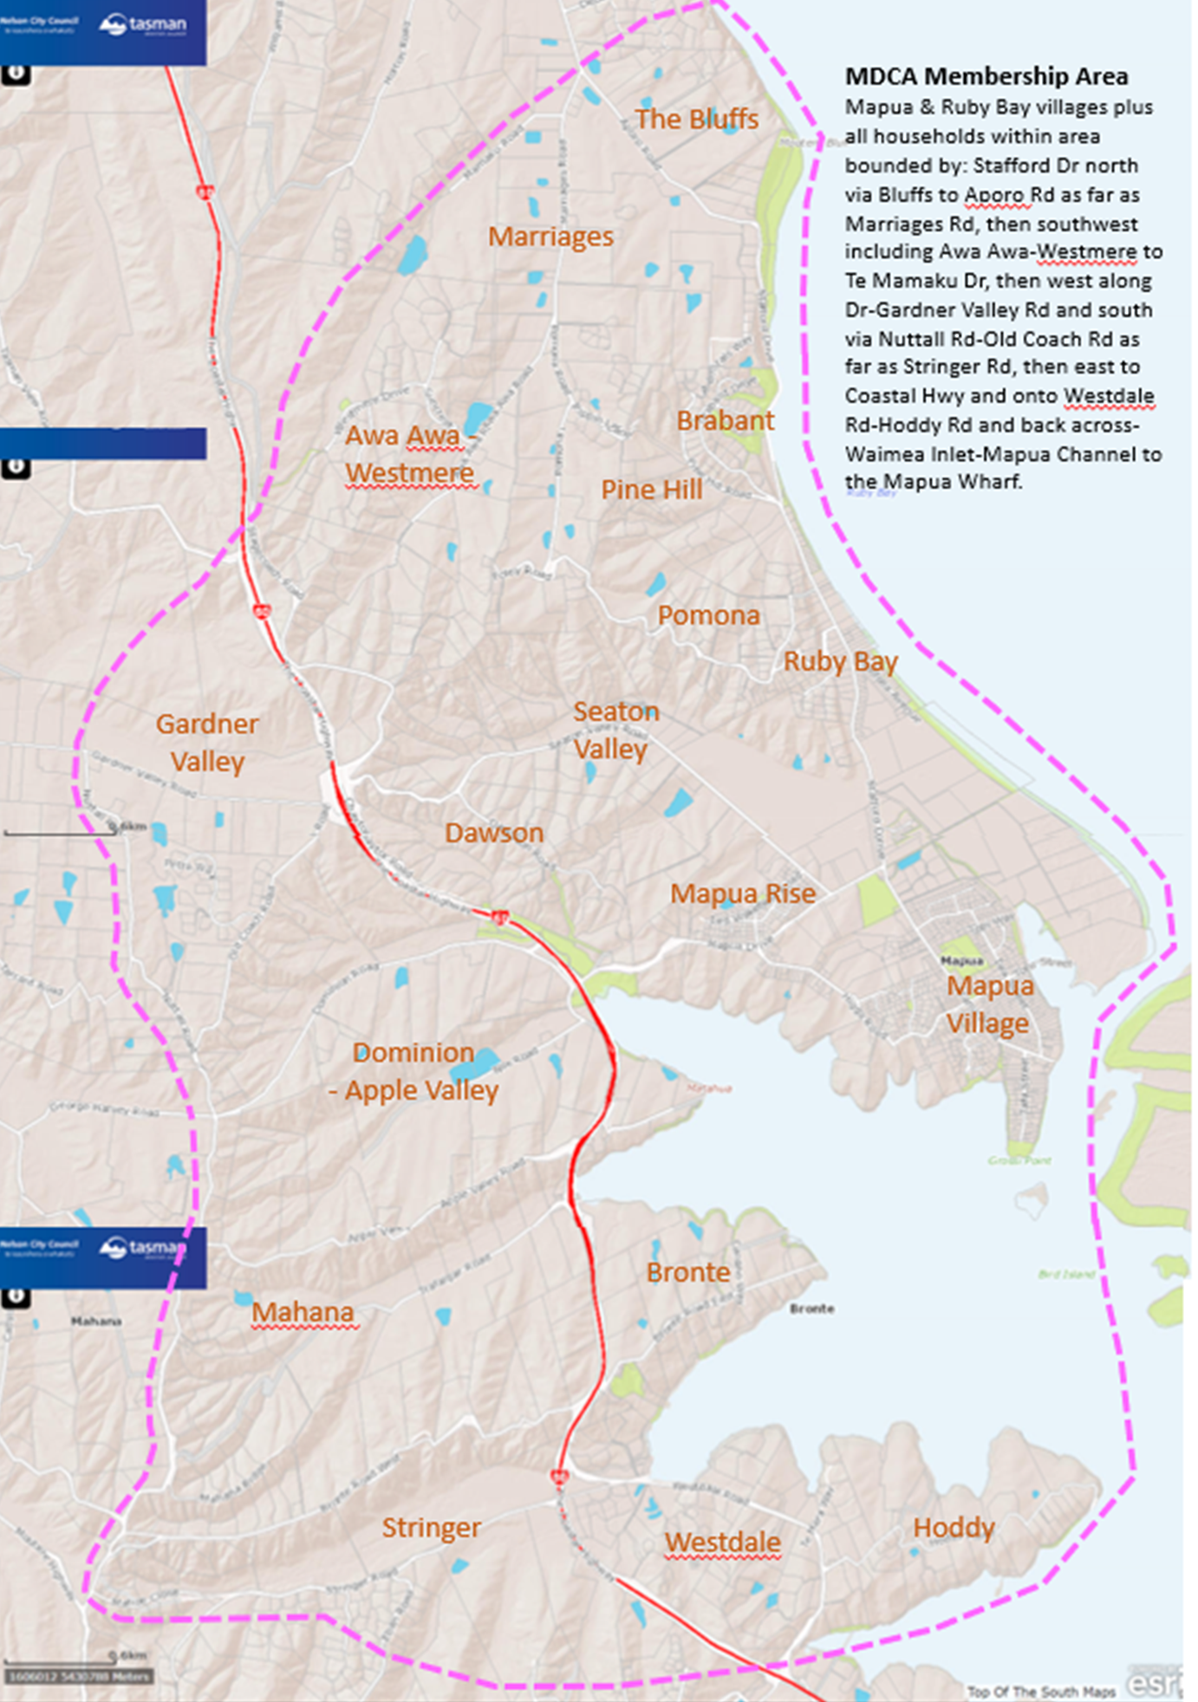

Appendix 2: Protocols and Guidelines for Managing MDCA Facebook
(Revision: June 2020)
The MDCA Facebook has been established to:
- Enable information on matters of community interest/concern and positions taken by the Assoc. to be disseminated to a far wider audience and demographic than the paid membership and those who attend monthly meetings.
- Solicit and receive responses, comments on and involvement in such matters from a wider and more representative cross-section of the community.
MDCA Facebook posting guidelines:
- The Executive Committee shall appoint a SM Manager Second from amongst its members to assume social media administration in case the Social Media Manager is unable to fulfil his/her responsibilities due to travel, illness or otherwise.
- The Facebook administrator shall post items of community interest – the wider the interest the better. Posts that involve advertising a product (rather than an event) should not be allowed unless the product is of general interest to the community.
- These posts will ask for feedback and comments in order to promote conversation.
- Submission of reasoned and well written “opinion” pieces is encouraged and these may be accepted and posted after review and editing by the administrator. All such articles will be headlined with: OPINION: [TITLE]; and the author’s name posted at article’s end.
- Name attribution is required for all submitted opinion pieces.
- The Facebook administrator will delete any comments that are offensive, e.g. racist, misogynistic, profane, promoting hate or those involving personal attacks.
- MDCA’s official posts should be clearly identified as such and be “objective” in stance, unless a clear unilateral position has been taken by the MDCA.
- MDCA resolutions on matters of community interest will be posted after each monthly meeting.
- 95% of all posts are “generic” (of general community interest) and do not require any outside authorization for the Administrator to post.
- MDCA Chair and one other selected Executive Committee member will serve as screeners of potentially “controversial” posts. If the Facebook administrator has any question about a post (including images) being appropriate for the MDCA Facebook page, he/she should seek confirmation from the 2 screeners.
- Screeners should have 24 hours to respond yeah or nay or provide edits. If no response is forthcoming, the administrator can use his/her best judgement as to what to post being cognizant of the above guidelines.
- The Facebook Administrator will report back to MDCA monthly meetings on Facebook
feedback received on substantive agenda items.
- In the case external groups OR organisations request MDCA to share information on their behalf, our policy is to share an original link (from a website or social media page). It can also be supported by a brief summary of key points from the original page that members may be interested in. If the information has not yet been publicly posted by the relevant group/organisation, MDCA would encourage them to publish it first before it is posted on the MDCA Facebook Page. In the case of identified community groups with direct links to MDCA and who report to MDCA monthly meetings (eg Waimea Inlet Forum) our policy is that MDCA will post their information, especially when this has been requested.

Appendix 3: Secretarial Duties and Procedures (Revision1 26May2024)
Executive Committee Meetings
Executive Committee Meetings occur two weeks before the General Meeting in a pre-determined schedule from 7 to 9 pm at the Māpua Community Hall.

Task | When | Who with
- Collate correspondence from Free parking webmail Secretary@ourmapua.org  - Prepare agenda with correspondence in it, get Chair’s changes  - Send correspondence files, minutes from previous executive mtg and current agenda to Exec members  - Take minutes of the meeting (using agenda as template)  - Write up & check minutes with Chairperson, then send to Exec members in MSWord format. After addressing changes save as a pdf labelled minutesexecmonthyear.pdf. | One week before mtg  One week before mtg  3 days before mtg  At the meeting  Within one week of the exec mtg | Chairperson  Chairperson
Handy Notes on Executive Meetings
The Executive Committee shall meet at least monthly(but need meet only once in the December-January period) as well as at such times and places and in such manner (including by audio, audio and visual, or electronic communication) as it may determine and otherwise where and as convened by the Chairperson or Secretary. The Secretary, or other Committee member nominated by the Committee, shall give to all Committee members not less than 5 Working Days’ notice of Committee meetings, but in cases of urgency a shorter period of notice shall suffice.

Check email before the meeting to catch any last-minute apologies. Show up on time. Take minutes including the following;
- Those attending and any apologies
- The acceptance or not of the previous minutes including the person who moved and the person who seconded as well as the outcome
- Record motions made, by whom, seconded and by whom, outcome of this motion
- Record action items and who is assigned to complete the action
- Include a summary of discussions on specific topics

Shortly after the executive meeting (within a day or two) edit your draft of the minutes and send to the Chair, exec committee members and anyone with action items to confirm. Allow two weeks for responses.
General Meetings
General Meetings are open to the public and occur on the fourth Monday of the month in a pre-determined schedule from 7 to 9 pm at the Māpua Community Hall.

Task | When | Who with
- Collate correspondence and monthly reports* from Free parking webmail Secretary@ourmapua.org  - Prepare agenda with correspondence and reports, get Chair’s changes  - Send correspondence files, reports from exec, minutes from previous General & Exec meetings to Social Media Coordinator for posting on the webpage  - Write monthly Mailchimp greeting* and do test run, check the test email at Secretary@ourmapua.org  - Mailchimp mailout to full mailing list  - Record attendances & take minutes of the meeting  - Write up & check minutes with Chairperson then send to Exec members in MSWord format  - Write article for the Coastal News with minutes from the meeting, check with chair then mail to news@coastalnews.online | Week before  Week before  Thursday before the meeting  Friday before the meeting  Friday before the meeting  At the meeting  1 week after meeting  Before the 20th of the month | Chairperson  Chairperson  Social Media portfolio  Social Media portfolio  Social Media portfolio  Chairperson  Chairperson
* Mailchimp document should include a welcome and a brief overview of the meeting highlights and any key topics that will be covered this month. Include a link to all the above files on the web page. The link for the year 2024 is https://www.ourmapua.org/2024-general-meetings/.
Handy Notes on General Meetings
Monday the day of the General Meeting, check email before the meeting to catch any last-minute apologies. Show up 20 minutes early to set up a table at the entrance with a sign-in sheet for attendees. A clipboard with preprinted forms belongs to MDCA.

Take minutes of the General Meeting including the following;
- Those attending (from sign-in sheet at the door) and any apologies
- The acceptance or not of the previous minutes including the person who moved and the person who seconded as well as the outcome
- Record action items, who is assigned to complete the action and decisions made
- Record TDC Councillors’ announcements
- Record votes taken, ensuring that only paid members are counted and
- Include a summary of discussions on specific topics

Shortly after the General Meeting (within a day or two) edit your draft of the minutes and send to the Chair, exec committee members and anyone with action items to confirm. Allow two weeks for responses.
AGM

The AGM is open to members only and occurs at the beginning of the August General Meeting

Task | When | Who with
- Collate annual reports from Portfolio holders  - Send formal notification of meeting to media outlets & invited guests  - Arrange nomination/seconding process for executive positions  - Compile Mailchimp of documents _ annual report; annual audited accounts; minutes of previous AGM & do test run with social media  - Mailchimp mailout to all members  - Record attendances & take minutes of the meeting  - Write up & check minutes with chairperson then file & send copies for deposit as required | Week before  Month before  Fortnight before  Week before  Week before  At the meeting  Week after the meeting | Chairperson  Chairperson/ social media portfolio  Chairperson

Correspondence
Collate correspondence and reports as they come in, saving as pdf format and using the naming convention detailed below. Add these to the correspondence for the Executive Meeting (if relevant) and into the new agenda for the General Meeting. Perform other correspondence roles as agreed at meetings with Chair’s consent

Agenda : Agenda_Executive_Meeting_Month_Year.pdf
Correspondence : Topic_Sender_Date.pdf
Reports (Chair, Treasurer, Community Groups etc.) : Topic_Sender_Date.pdf
Minutes from previous Executive Meeting : Minutes_Exec_Month_Year.pdf
Minutes from previous General Meeting : Minutes_General_Date.pdf

Note - I like to send the Councillor reports in the General Meeting minutes back to the Councillors to get their edits before I send out the minutes from the General Meeting. - LMG

Mailing out the monthly notice using Mailchimp (instructions from Bruno)
Login go to login.mailchimp.com (get password from Bruno)
Email: info@ourmapua.org
Username: info@ourmapua.org

Upload all files to website (Bruno to do this)
The link address changes once a year (in January). This year it is https://www.ourmapua.org/2024-meetings/. However, if you use a previous mailchimp, the link should already be there.

To use a previous mailout and modify it follow these instructions:
Next to a previously sent email (eg February 12th), use the down arrow next to “View Report” and select “Replicate”. Go to the replication and change the heading to what you want (eg remove “copy 01” from the heading), “Edit Subject” putting in the correct date, then click save. The other sections don’t need changing except the Design section. Click on the “Edit Design” and to make changes to the first block of text labelled “MDCA Monthly Meeting”, by clicking on it. The other blocks (including the button block), should NOT need changing.

Else you can use a previous template (bit more complicated) but don’t go back before March 2023 as the link in the button was different before that.

The button link URL won’t need changing till January 2025.
Add other buttons if needed – to add a button, save and close, then a list of options will come up on what to insert.

Click “Continue” when done.
DO NOT press “send” until you have pressed “send a test email”. There is nothing worse than sending multiple emails to our members because of a mistake in the first one. Make sure you test the button in the test email. To be doubly sure, send your test email to another user (eg the chairperson or secretary).

Managing the Audience – Bruno does this annually
To add names: You can do a bulk import from a spreadsheet or you can add one member at a time. I have never done a bulk import and just add a member when needed.

I don’t remove old members because if they re-join it is easy to reactivate them.
It is useful to tag paid up members differently from members who have not yet paid. That way you can target non-paid up members with a reminder email.
This involved changing the tag from “member” to “old member” when they haven’t paid up and reversing that when they pay.

To prevent non-paid up members from receiving emails:
To choose the audience under “To”, click on “Edit Recipients”
There are 2 boxes, the first one says “All subscribers” – leave that one as is.
In the second box that says “Do not send to (optional)” click on the ˅ and then choose the tag “old members”.
That will exclude non-paid up members from receiving the Mailchimp email. That’s if you want non-paid up members to stop receiving Mailchimp emails before they have had time to pay up.

